**Customer process for concealed (hidden) damage application**

**Approval conditions for concealed damage application**

1. Customer’s application must to be done at the latest 45 days after the delivery
2. No transport must occur after the initial delivery at the specified address on Panasonic delivery note.

**Documents to be provided by customer**

1. Intact / very good shape carton picture
2. Damaged product pictures
3. Product serial number picture AND carton serial number picture
4. Transportation label
5. Excel application form filled, signed, stamped with invoice number or delivery note number. By signing this document, Customer commits to scrap the product by their means.

**Every scrapping evidence will be transmitted to Panasonic on demand.**



**Correct example of concealed damage case :**

* **Clean POD**

1. **Damaged product picture**

* **Excel Form :**

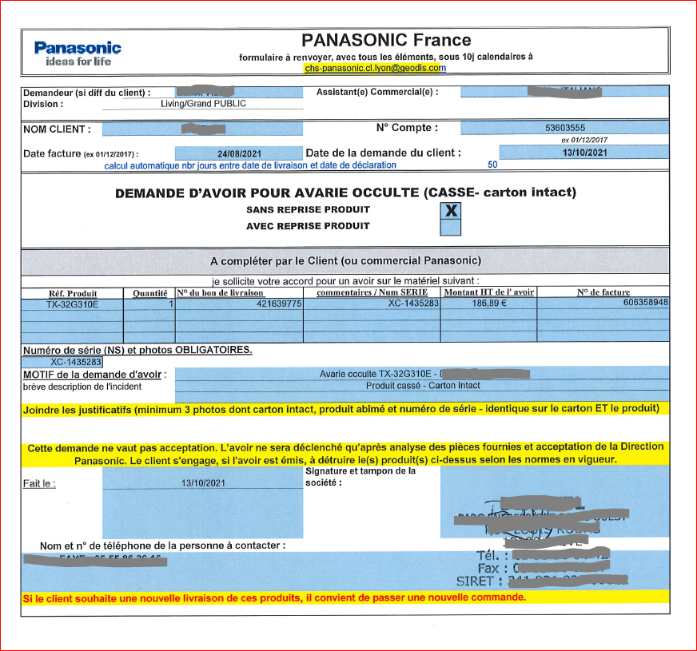

* **Intact carton :**

* **Carton serial :**

* **Product serial**

